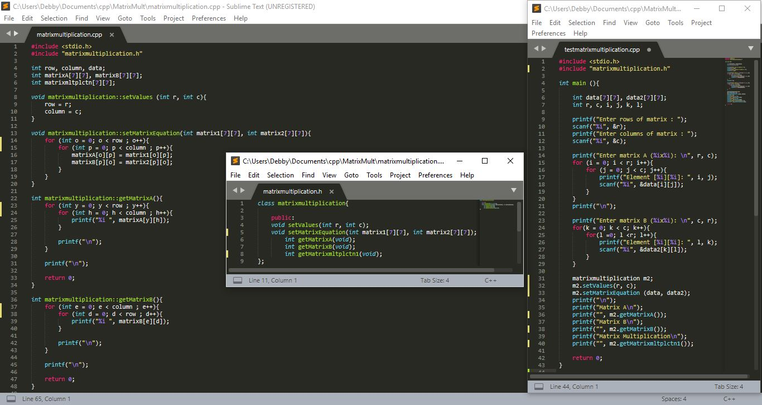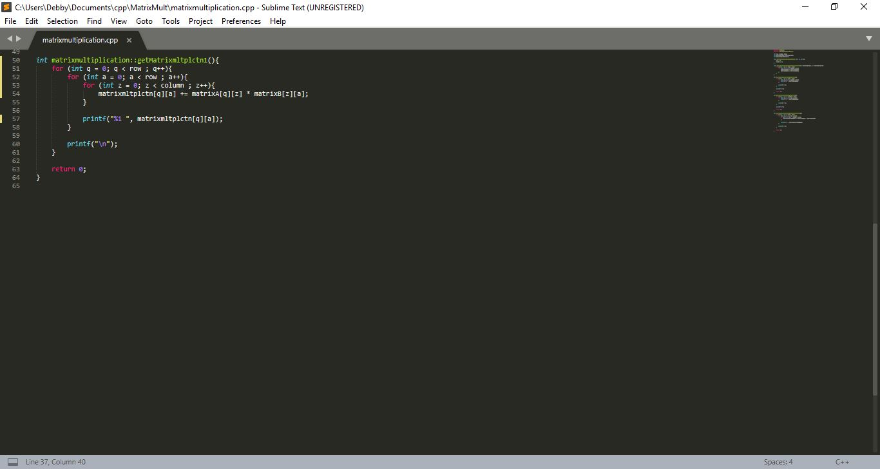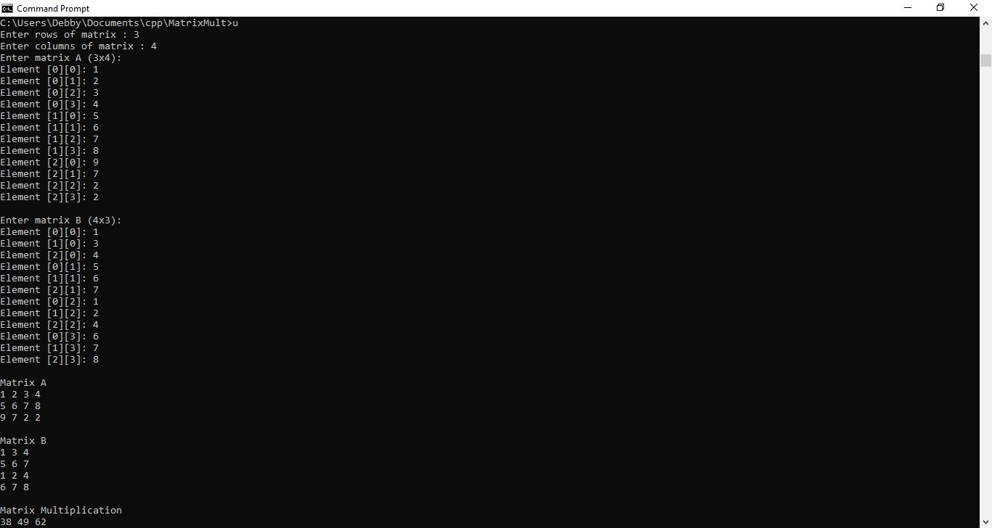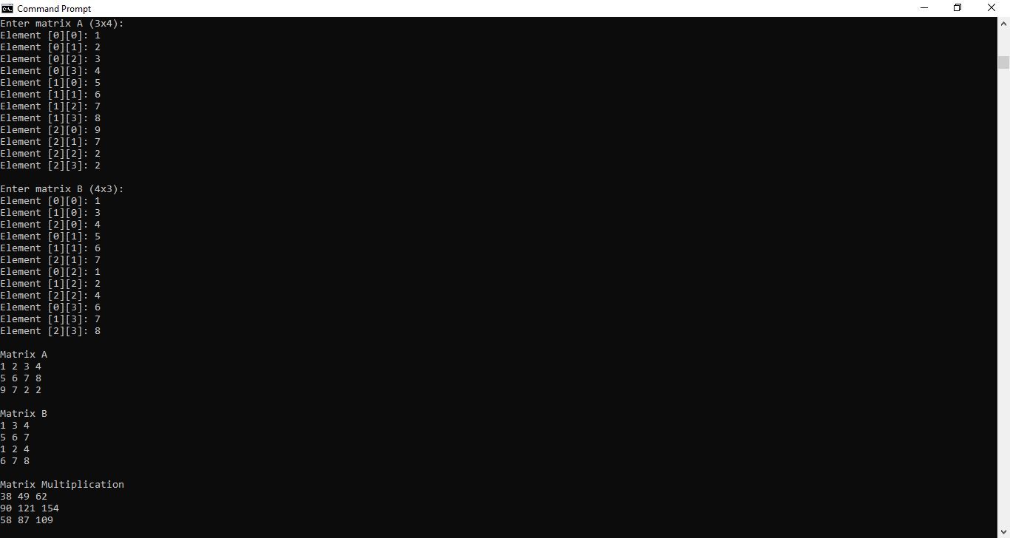

The first picture is combined file that consist of

1. matrixmultiplication.cpp - it was the class (location on the right)
2. matrixmultiplication.h - it was the classfile (location on the middle)
3. testmatrixmultiplication.cpp - it was the test file (location on the left)

then the second picture was the continued code from the previous file.

Then the 3&4 picture shows the code that was already compiled it into command prompt.

Matrix A $\left(\begin{matrix}1 & 2 & 3 \\ 5 & 6 & 7 \\ 9 & 7 & 2\end{matrix} \begin{matrix}4 \\ 8 \\ 2\end{matrix}\right)$ matrix multiplication:

Matrix B $\left(\begin{matrix}1 & 3 & 4 \\ 5 & 6 & 7 \\ 1 & 2 & 4 \\ 6 & 7 & 8\end{matrix} \right)$ $\left(\begin{matrix}38 & 49 \\ 90 & 121 \\ 58 & 87\end{matrix} \begin{matrix}62 \\ 154 \\ 109\end{matrix}\right)$